**Different types of Mobile APPs:**

1. **Native Apps:**

Native apps are the apps which has been developed and compiled using Specific Programming language for specific platform. They are also built using the specific Integrated Development Environment (IDE) for the given operating systems, such as Android Studio for Android Apps and XCode for iOS Apps and Visual Studio for Windows Apps.

Let us see what languages they use to develop the Native application for Android, iOS and Windows.

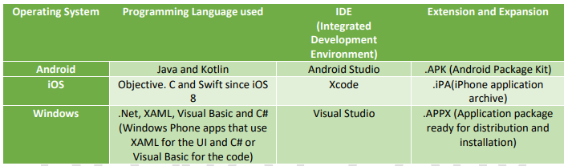

**Benefits of Native Apps:**

* Native apps have full access to platform specific hardware and software features
* Native apps maintain UI Designs of each OS and Provides rich user experience
* Native apps takes full advantages of the devices features like Camera, GPS, Sensors etc.
* Native apps uses the device notification system and can work offline
* Native apps provides fast performance and a high degree of reliability and provides most responsive experience Some native apps can be accessed without internet connection but the new contents will not be downloaded or displayed.

**Drawbacks of Native Apps:**

* The amount of development work is increased with each supported platforms because of its own code base
* Code which has been used to build application can’t be reused to other platform due to different programming languages. Example: App developed for iOS code can’t be reused for Android app.
* More cost and time is required to develop specific versions due to this development costs can be higher.

1. **Web Apps:**

Mobile Web apps are device-neutral and it is mobile-friendly websites, and since those websites are specific for mobile devices, they are called web apps.

Web apps are commonly build using CSS3, HTML5, and JavaScript and can be reached by typing in a specific URL into your browsers. Some web apps are built specifically as mobile websites, whereas others are responsive Web apps that are optimized for multiple sizes of devices, including a desktop Here website are optimized for Mobile browser usage and are independent of the mobile platform. Most of the browsers doesn’t support full standard of HTML5, CSS3 and JavaScript some websites may behave differently on Mobile Browsers.

**Drawbacks of Web Apps:**

* Mobile Web apps only have limited scope as far as accessing a mobile device’s features is concerned. Different users work with different mobile browsers. This can make it difficult for you to maintain a record of their usage patterns and also provide support for all of them.
* Limited offline behavior, Always required internet to access any website.
* Since there is no regularized quality control system for Web apps, users may not always be guaranteed safety and security of the app.

The online experience via a mobile phone is hardly ideal.

Until now, mobile Internet users had two options when browsing online.

They could either use a responsive website, which suffers slow loading times that can cause users to drop off, or they could use an app. Frances Berriman and Alex Russell came up with a concept called Progressive Web Apps.

1. **Progressive Web Apps:**

A Progressive web apps is a web apps that uses modern capabilities to deliver an app like experience to users without requiring them to install an app from the App Store/Play Store and these apps meet certain requirements and deployed to servers and accessible through URL’s and indexed by search engines. PWA is a combination of best of web and best of Native apps. Progressive web apps are web apps which combines the best features of web and native apps. It is progressive because it is constantly progressing

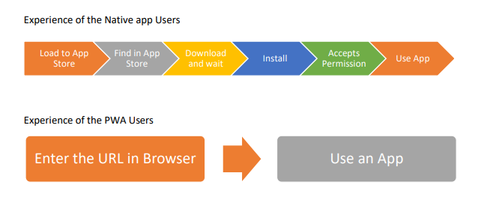

**Problems in Native Apps:**

We all have used android and iOS apps on our smartphones. We use them for all kinds of thing. But while installing any Android / iOS apps we go through these problems

a) Is this worth to download an app?

b) Do I have enough space in mobile device?

c) Is my sufficient data is available

**Characteristics of Progressive Web Apps:**

* Progressive Works for every Users regardless of Browser choice because they have built with progressive enhancement at its core
* Responsive Fits any Form Factor: Desktop, Mobile and Tablet Fresh Auto Refresh after each content update enabling viewers to immediate enjoy the new features without need to re-downloading the app
* App-Like Uses the app-shell model to provide app-style navigation and interactions Installable Users can save it to their home screen without the hassle of actually downloading an app
* Linkable Easily sharable with the URL that launch the users straight into the app without the complex installation process.
* Fast Enhanced with networks allowing the app to work offline and with low quality networks.

**Benefits of PWA over Native app:**

1. Cost Effective

ii) Cross Platform as it is not restricted to any specific platform

In the below representation, the user asks for some content they have accessed before but due to unavailability of the network, the latest content cannot be fetched. Here service worker performs its magic and tries to fulfill the request via cache to provide better user experience. And once the network is up again, it can update the cached information with latest one on the basis of caching strategy being used.

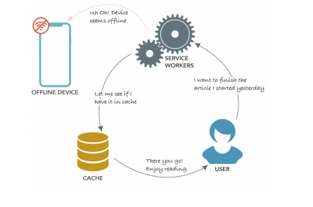

1. Hybrid Apps :

Hybrid apps are essentially Web content wrapped in a native container. This type uses skeleton native apps, loads web content that can be static or dynamic, runs on the device. The functionality like camera or contacts can be applied due to the skeleton native apps.

Benefits of Hybrid Apps:

* It takes all benefits of Native application

Write once deploy anywhere, web app code can be reused across different platform, Low development cost compared to Native apps.

* Hybrid mobile apps don’t have that “mobile web” browser look because they can include native hardware features.
* The content of a hybrid app is portable and just requires a native harness to run it.

**Drawbacks of Hybrid Apps:**

* Lack of the pure UI assets of iOS or Android may result in a slower performance of the app in general. It may not look like a mobile website, but it may feel like it at certain points. Since most hybrid apps are written in HTML5, they rely on the system’s browser to support the native wrapper.
* As most of the Hybrid apps written in HTML5 they depend on internet to load contents.

1. **Cross Platform Apps :**

Cross platform app development provide great cost saving advantage by developing one application that run over multiple platforms such as iPhone, Android, Windows and Blackberry. It allows a single source development approach to deploy on various platform with minimum charges. Cross platform apps refers to WORA (Write ones run anywhere) here piece of code that’s written once in a platform but can run on multiple-platforms. Below are the list of Cross Platform development tools, Platform support and Languages used



